Logging into Email

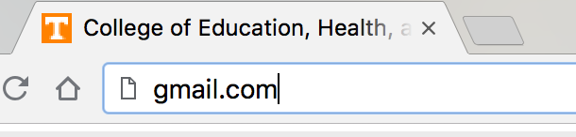

_________ Type into address bar: gmail.com

_________ Type in your volmail address: Your username @vols.utk.edu
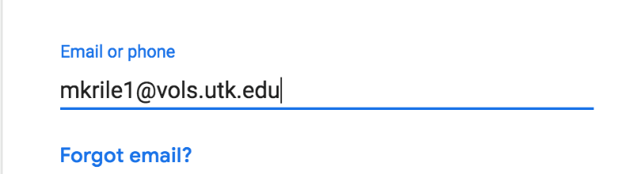

_________ Press Enter or Click on Next

_________ Enter your NetID Password
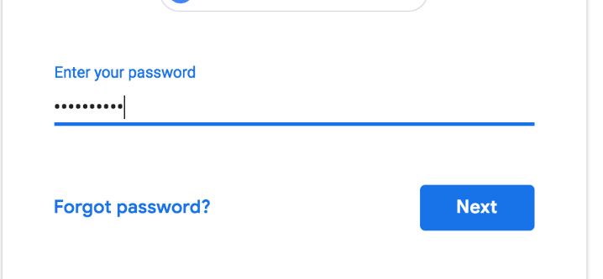

_________ Press Enter or Left Click on Next

You have logged into your email!

Sending Emails

_________ Left click on Compose

_________ Type in mkrile1@vols.utk.edu in the To line

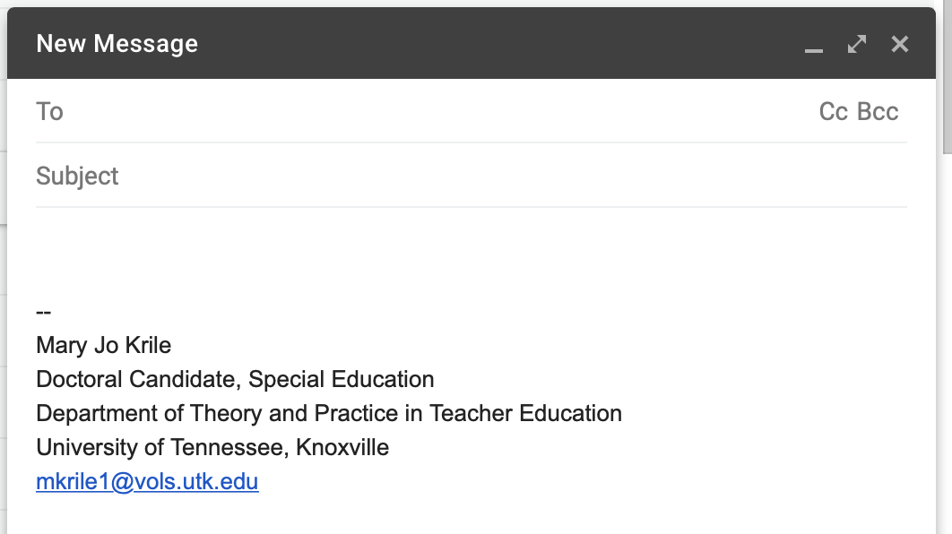
mkrile1@vols.utk.edu

_________ Type your name in the Subject line

Your Name

_________ Left click in text box and type your answer to:
What is your favorite place to visit?

What is your favorite place to visit?

_________ Type your name at the end of your email

Deleting Emails

_________ Left click on Send

Other Helpful Information

Insert picture
Insert file from Google Drive
Insert emoji
Attach file
Change font size, type, or color

