ACTION PLAN – Montana State Deaf-Blind Project

Webinar #3

“Unique Learning Needs of Learners Who Experience Deaf-Blindness”
“Building Structure Through the Use of Routines”

Name
- What “big idea” did you gain from this webinar that you plan to apply in your family interaction / daily educational practice?

- What is one thing you want to remember OR that you plan to do differently, when interacting with a learner who experiences deafblindness, after this webinar?

- Action Plan
Goal / Action Step  (What do you want to remember?) | Resources I Need to Act on this Information / Step | Evaluation: How Will I Know I Accomplished What I Needed?

- What remaining questions do you have after this webinar?

Sincere thanks for your participation!
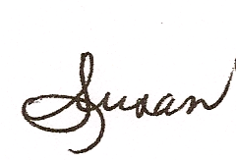
Susan M. Bashinski
sbashinski@gmail.com
785-424-0804

